**Spring REST using Spring Boot 3**

**Create a Spring Web Project using Maven**

**Code:**

**//SpringLearnApplication.java**

package com.cognizant.spring_learn;

import org.slf4j.Logger;

import org.slf4j.LoggerFactory;

import org.springframework.boot.SpringApplication;

import org.springframework.boot.autoconfigure.SpringBootApplication;

@SpringBootApplication

public class SpringLearnApplication {

private static final Logger LOGGER = LoggerFactory.getLogger(SpringLearnApplication.class);

public static void main(String[] args) {

SpringApplication.run(SpringLearnApplication.class, args);

LOGGER.info("Inside main");

}

}

**Output:**

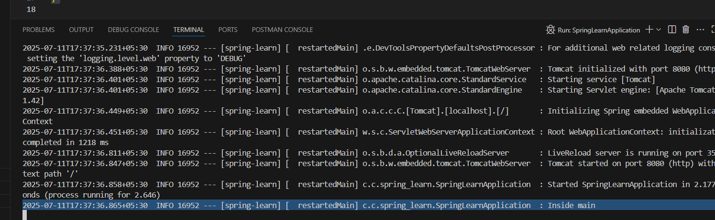

**Spring Core – Load Country from Spring Configuration XML**

**Code:**

**<!--country.xml-->**

<?xml version="1.0" encoding="UTF-8"?>

<beans xmlns="http://www.springframework.org/schema/beans"

xmlns:xsi="http://www.w3.org/2001/XMLSchema-instance"

xsi:schemaLocation="http://www.springframework.org/schema/beans

http://www.springframework.org/schema/beans/spring-beans.xsd">

<bean id="country" class="com.cognizant.springlearn.Country">

<property name="code" value="IN"/>

<property name="name" value="India"/>

</bean>

</beans>

**//Country.java**

package com.cognizant.spring_learn;

import org.slf4j.Logger;

import org.slf4j.LoggerFactory;

public class Country {

private static final Logger LOGGER = LoggerFactory.getLogger(Country.class);

private String code;

private String name;

public Country() {

LOGGER.debug("Inside Country Constructor.");

}

public String getCode() {

LOGGER.debug("Inside getCode");

return code;

}

public void setCode(String code) {

LOGGER.debug("Inside setCode");

this.code = code;

}

public String getName() {

LOGGER.debug("Inside getName");

return name;

}

public void setName(String name) {

LOGGER.debug("Inside setName");

this.name = name;

}

@Override

public String toString() {

return "Country{" +

"code='" + code + '\'' +

", name='" + name + '\'' +

'}';

}

}

**//SpringLearnApplication.java**

package com.cognizant.spring_learn;

import org.slf4j.Logger;

import org.slf4j.LoggerFactory;

import org.springframework.boot.SpringApplication;

import org.springframework.context.ApplicationContext;

import org.springframework.boot.autoconfigure.SpringBootApplication;

import org.springframework.context.support.ClassPathXmlApplicationContext;

@SpringBootApplication

public class SpringLearnApplication {

private static final Logger LOGGER = LoggerFactory.getLogger(SpringLearnApplication.class);

public static void main(String[] args) {

SpringApplication.run(SpringLearnApplication.class, args);

LOGGER.info("Inside main");

displayCountry();

}

public static void displayCountry() {

ApplicationContext context = new ClassPathXmlApplicationContext("country.xml");

Country country = context.getBean("country", Country.class);

LOGGER.debug("Country : {}", country.toString());

}

}

**Output:**

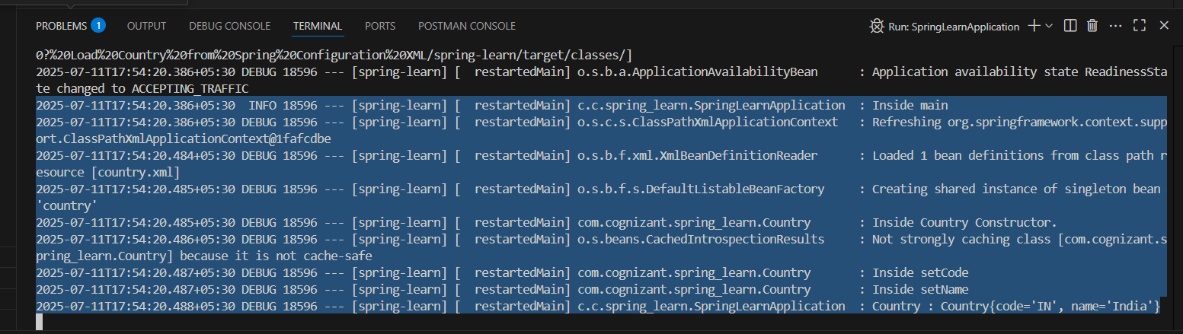

**Hello World RESTful Web Service**

**Code:**

**//HelloController.java**

package com.cognizant.spring_learn.controller;

import org.slf4j.Logger;

import org.slf4j.LoggerFactory;

import org.springframework.web.bind.annotation.GetMapping;

import org.springframework.web.bind.annotation.RestController;

@RestController

public class HelloController {

private static final Logger LOGGER = LoggerFactory.getLogger(HelloController.class);

@GetMapping("/hello")

public String sayHello() {

LOGGER.info("START - sayHello()");

String response = "Hello World!!";

LOGGER.info("END - sayHello()");

return response;

}

}

**//SpringLearnApplication.java**

package com.cognizant.spring_learn;

import org.slf4j.Logger;

import org.slf4j.LoggerFactory;

import org.springframework.boot.SpringApplication;

import org.springframework.boot.autoconfigure.SpringBootApplication;

@SpringBootApplication

public class SpringLearnApplication {

private static final Logger LOGGER = LoggerFactory.getLogger(SpringLearnApplication.class);

public static void main(String[] args) {

SpringApplication.run(SpringLearnApplication.class, args);

LOGGER.info("Inside main");

}

}

**Output:**

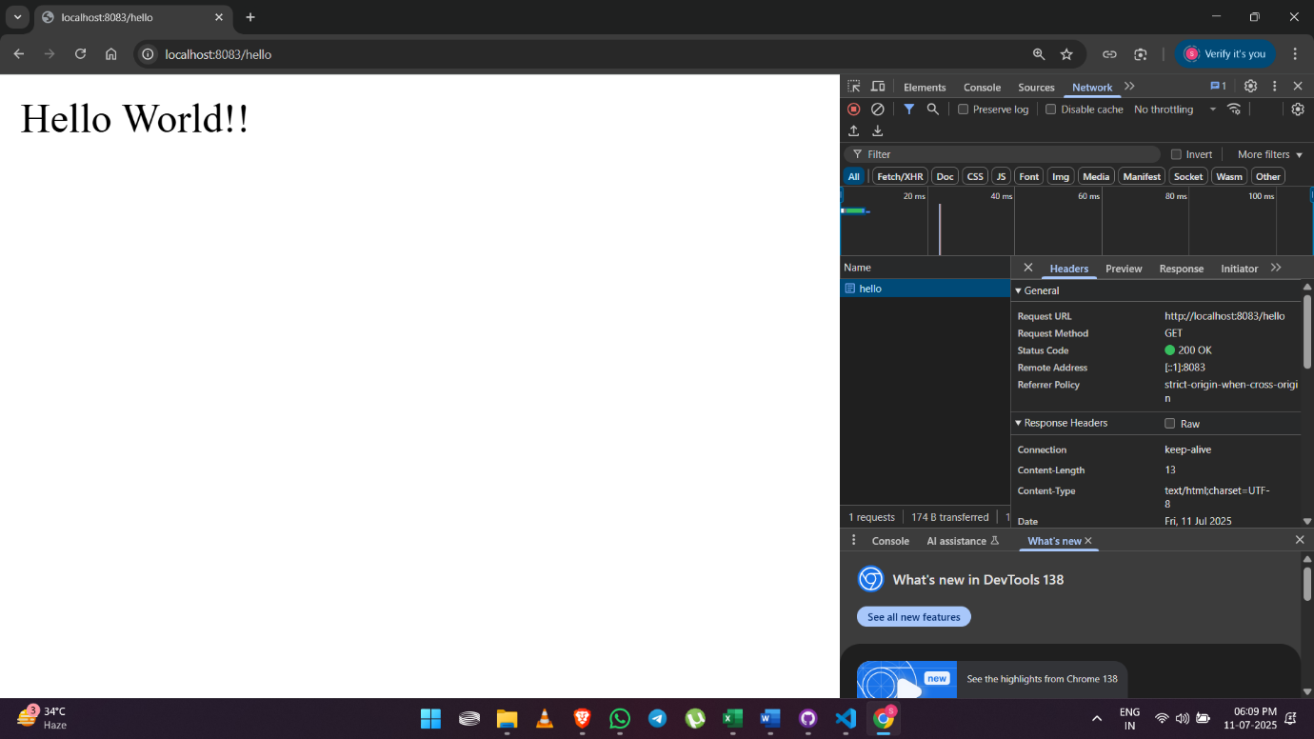

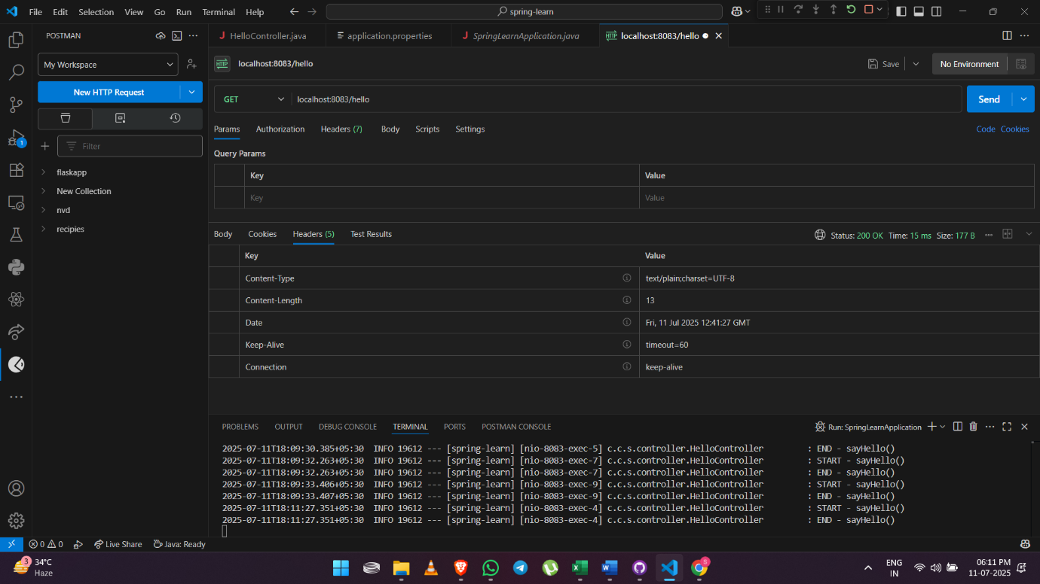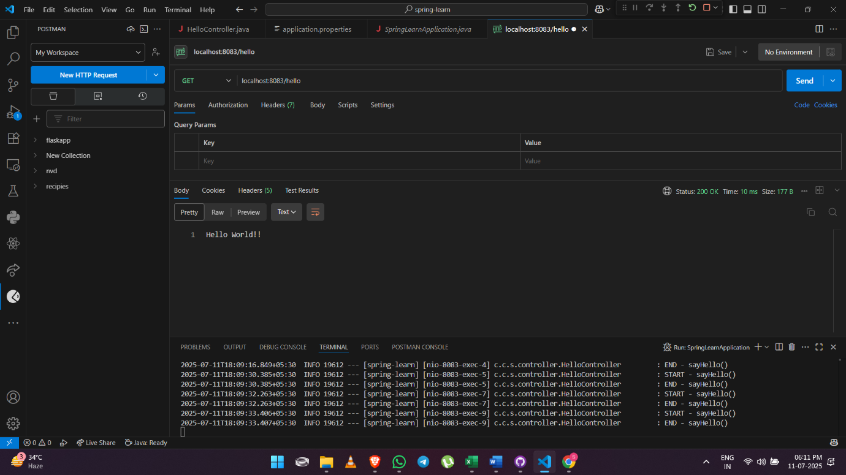

**REST - Country Web Service**

**Code:**

**//Country.java**

package com.cognizant.spring_learn.model;

public class Country {

private String code;

private String name;

public String getCode() {

return code;

}

public void setCode(String code) {

this.code = code;

}

public String getName() {

return name;

}

public void setName(String name) {

this.name = name;

}

}

**<!--country.xml-->**

<?xml version="1.0" encoding="UTF-8"?>

<beans xmlns="http://www.springframework.org/schema/beans"

xmlns:xsi="http://www.w3.org/2001/XMLSchema-instance"

xsi:schemaLocation="http://www.springframework.org/schema/beans

http://www.springframework.org/schema/beans/spring-beans.xsd">

<bean id="country" class="com.cognizant.spring_learn.model.Country">

<property name="code" value="IN"/>

<property name="name" value="India"/>

</bean>

</beans>

**//CountryController.java**

package com.cognizant.spring_learn.controller;

import com.cognizant.spring_learn.model.Country;

import org.springframework.context.ApplicationContext;

import org.springframework.context.support.ClassPathXmlApplicationContext;

import org.springframework.web.bind.annotation.RequestMapping;

import org.springframework.web.bind.annotation.RestController;

@RestController

public class CountryController {

@RequestMapping("/country")

public Country getCountryIndia() {

ApplicationContext context = new ClassPathXmlApplicationContext("country.xml");

Country country = (Country) context.getBean("country");

return country;

}

}

**//SpringLearnApplication.java**

package com.cognizant.spring_learn;

import org.slf4j.Logger;

import org.slf4j.LoggerFactory;

import org.springframework.boot.SpringApplication;

import org.springframework.boot.autoconfigure.SpringBootApplication;

@SpringBootApplication

public class SpringLearnApplication {

private static final Logger LOGGER = LoggerFactory.getLogger(SpringLearnApplication.class);

public static void main(String[] args) {

SpringApplication.run(SpringLearnApplication.class, args);

LOGGER.info("Inside main");

}

}

**Output:**

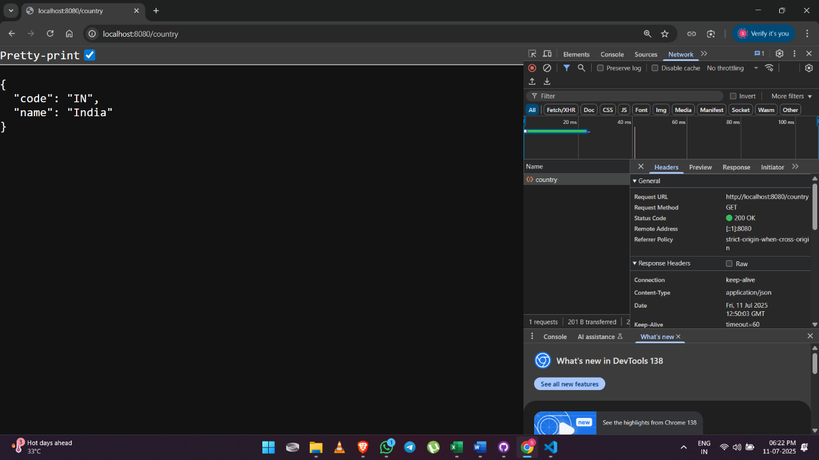

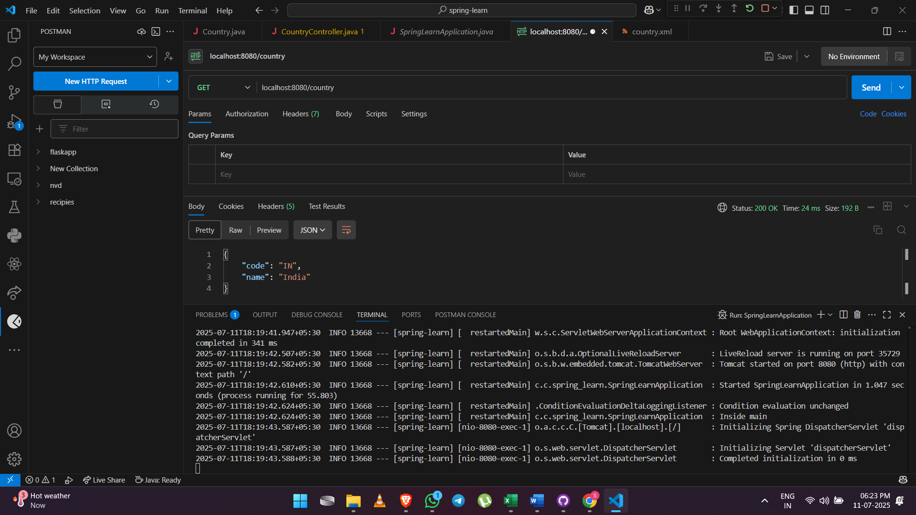

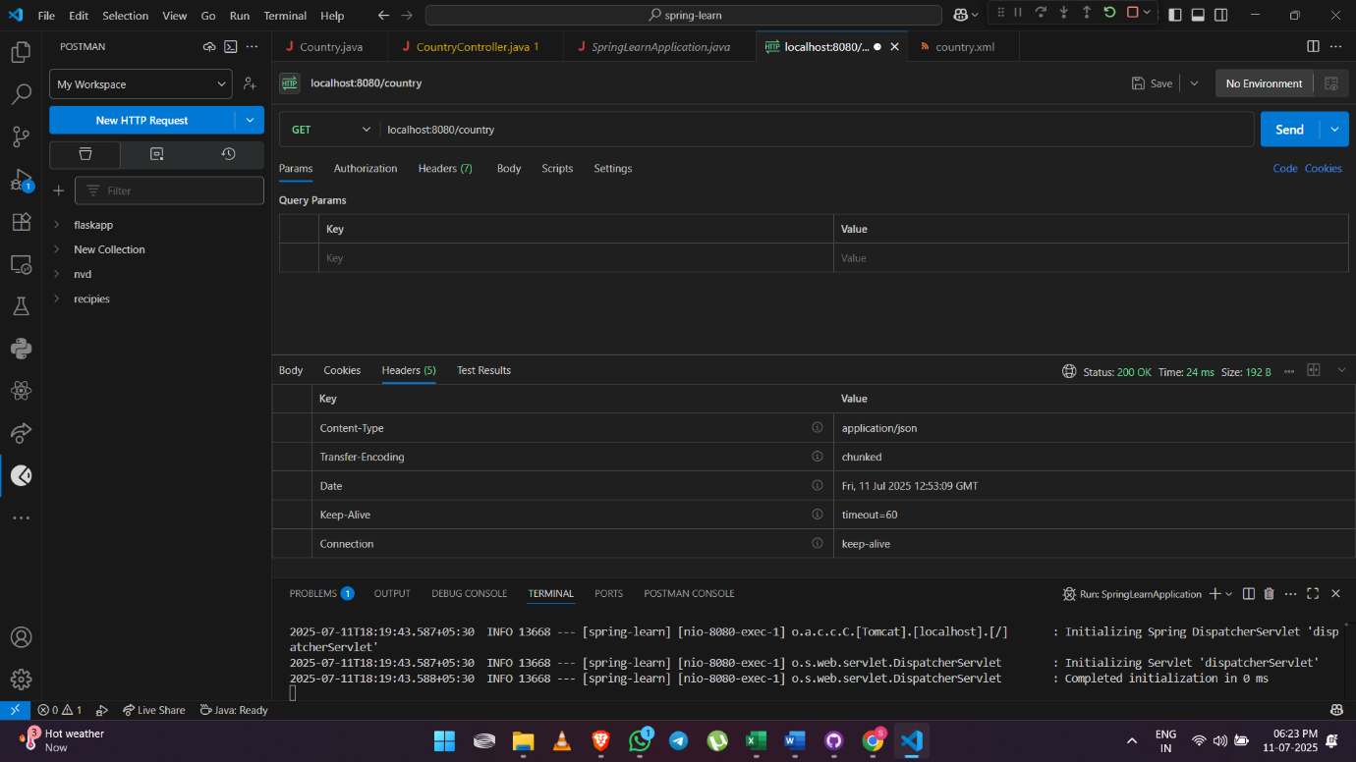

**REST - Get country based on country code**

**Code:**

**//Country.java**

package com.cognizant.spring_learn.model;

public class Country {

private String code;

private String name;

public String getCode() {

return code;

}

public void setCode(String code) {

this.code = code;

}

public String getName() {

return name;

}

public void setName(String name) {

this.name = name;

}

}

**<!--country.xml-->**

<?xml version="1.0" encoding="UTF-8"?>

<beans xmlns="http://www.springframework.org/schema/beans"

xmlns:xsi="http://www.w3.org/2001/XMLSchema-instance"

xsi:schemaLocation="http://www.springframework.org/schema/beans

http://www.springframework.org/schema/beans/spring-beans.xsd">

<bean id="country" class="com.cognizant.spring_learn.model.Country">

<property name="code" value="IN"/>

<property name="name" value="India"/>

</bean>

<bean id="countryList" class="java.util.ArrayList">

<constructor-arg>

<list>

<bean class="com.cognizant.spring_learn.model.Country">

<property name="code" value="IN"/>

<property name="name" value="India"/>

</bean>

<bean class="com.cognizant.spring_learn.model.Country">

<property name="code" value="US"/>

<property name="name" value="United States"/>

</bean>

<bean class="com.cognizant.spring_learn.model.Country">

<property name="code" value="UK"/>

<property name="name" value="United Kingdom"/>

</bean>

</list>

</constructor-arg>

</bean>

</beans>

**//CountryService.java**

package com.cognizant.spring_learn.service;

import com.cognizant.spring_learn.model.Country;

import org.springframework.context.ApplicationContext;

import org.springframework.context.support.ClassPathXmlApplicationContext;

import org.springframework.stereotype.Service;

import java.util.List;

@Service

public class CountryService {

public Country getCountry(String code) {

ApplicationContext context = new ClassPathXmlApplicationContext("country.xml");

List<Country> countryList = (List<Country>) context.getBean("countryList");

return countryList.stream()

.filter(c -> c.getCode().equalsIgnoreCase(code))

.findFirst()

.orElse(null); // or throw a custom exception

}

}

**//CountryController.java**

package com.cognizant.spring_learn.controller;

import com.cognizant.spring_learn.model.Country;

import com.cognizant.spring_learn.service.CountryService;

import org.springframework.beans.factory.annotation.Autowired;

import org.springframework.context.ApplicationContext;

import org.springframework.context.support.ClassPathXmlApplicationContext;

import org.springframework.web.bind.annotation.*;

@RestController

public class CountryController {

@Autowired

private CountryService countryService;

@RequestMapping("/country")

public Country getCountryIndia() {

ApplicationContext context = new ClassPathXmlApplicationContext("country.xml");

Country country = (Country) context.getBean("country");

return country;

}

@GetMapping("/countries/{code}")

public Country getCountry(@PathVariable String code) {

return countryService.getCountry(code);

}

}

**//SpringLearnApplication.java**

package com.cognizant.spring_learn;

import org.slf4j.Logger;

import org.slf4j.LoggerFactory;

import org.springframework.boot.SpringApplication;

import org.springframework.boot.autoconfigure.SpringBootApplication;

@SpringBootApplication

public class SpringLearnApplication {

private static final Logger LOGGER = LoggerFactory.getLogger(SpringLearnApplication.class);

public static void main(String[] args) {

SpringApplication.run(SpringLearnApplication.class, args);

LOGGER.info("Inside main");

}

}

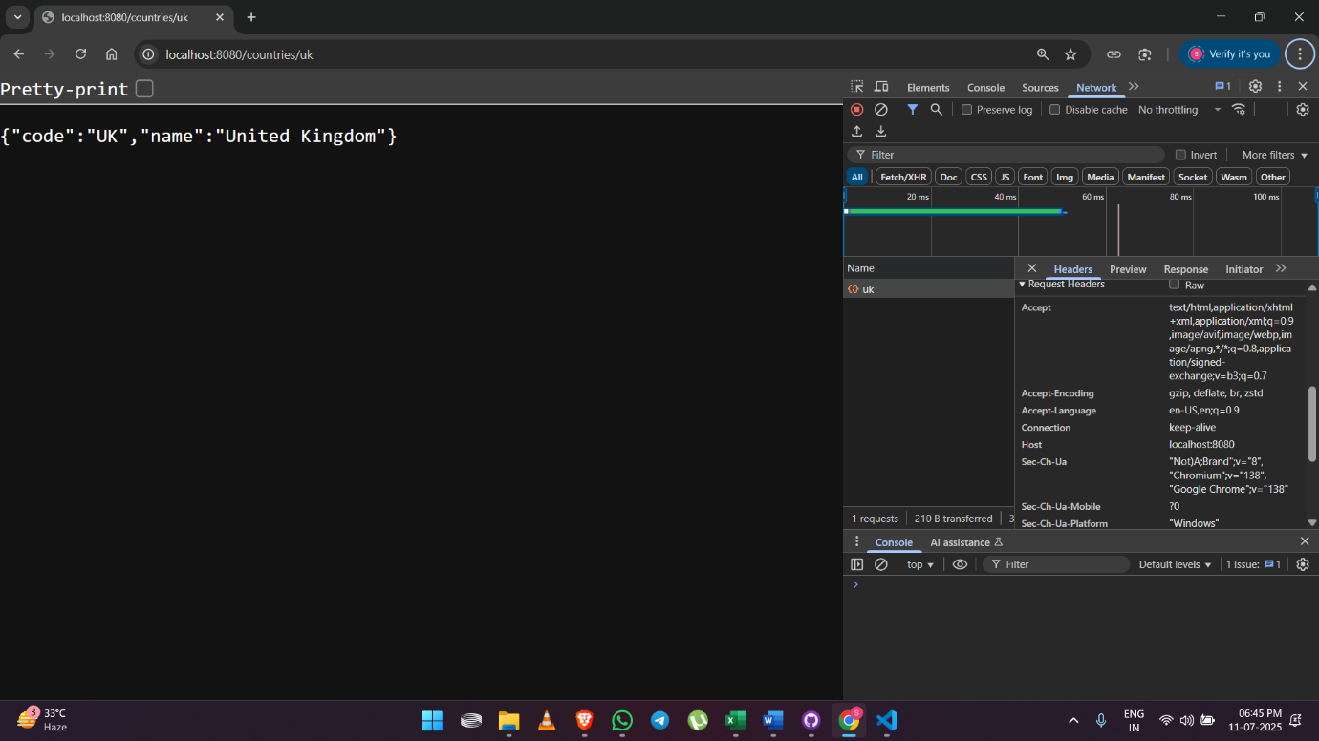**Output:**

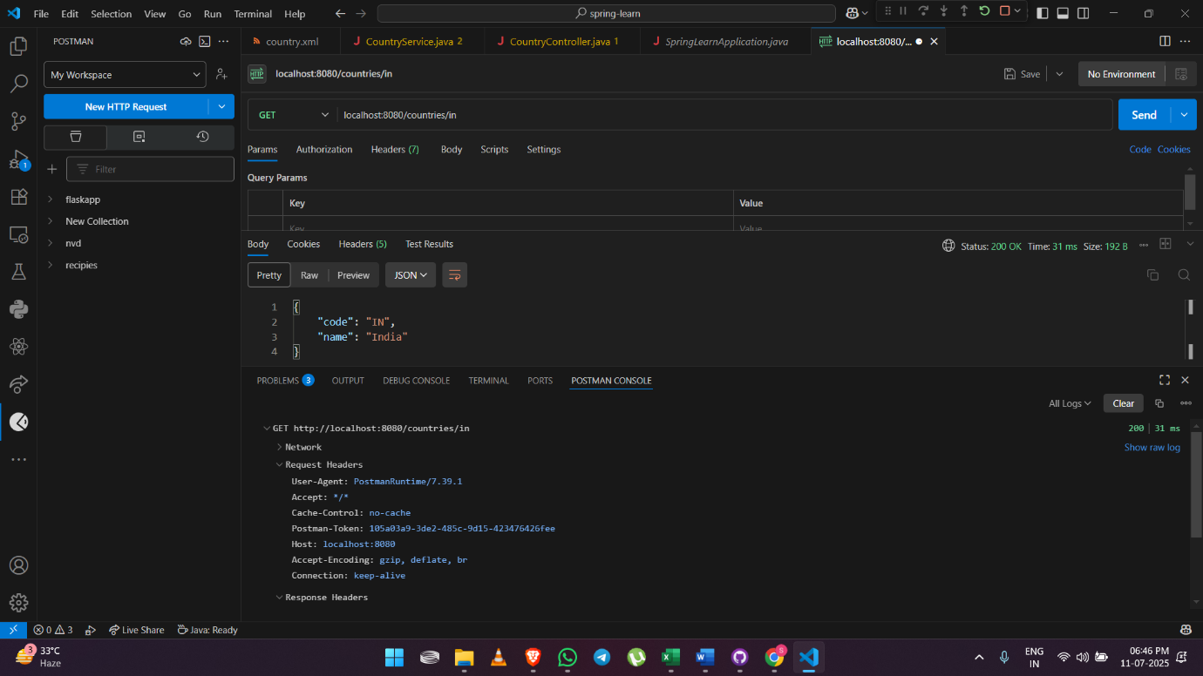

**Create authentication service that returns JWT**

**Code:**

**//SecurityConfig.java**

package com.cognizant.spring_learn;

import org.springframework.context.annotation.Bean;

import org.springframework.context.annotation.Configuration;

import org.springframework.security.config.annotation.web.builders.HttpSecurity;

import org.springframework.security.web.SecurityFilterChain;

import org.springframework.security.crypto.bcrypt.BCryptPasswordEncoder;

import org.springframework.security.crypto.password.PasswordEncoder;

import org.springframework.security.config.Customizer;

import org.springframework.security.config.annotation.method.configuration.EnableMethodSecurity;

import org.springframework.security.provisioning.InMemoryUserDetailsManager;

import org.springframework.security.core.userdetails.User;

import org.springframework.security.core.userdetails.UserDetails;

@Configuration

@EnableMethodSecurity

public class SecurityConfig {

@Bean

public InMemoryUserDetailsManager userDetailsService(PasswordEncoder passwordEncoder) {

UserDetails user = User.withUsername("user")

.password(passwordEncoder.encode("pwd"))

.roles("USER")

.build();

UserDetails admin = User.withUsername("admin")

.password(passwordEncoder.encode("adminpwd"))

.roles("ADMIN")

.build();

return new InMemoryUserDetailsManager(user, admin);

}

@Bean

public SecurityFilterChain filterChain(HttpSecurity http) throws Exception {

http.csrf(csrf -> csrf.disable())

.authorizeHttpRequests(auth -> auth

.requestMatchers("/countries").hasRole("USER")

.requestMatchers("/authenticate").hasAnyRole("USER", "ADMIN")

.anyRequest().authenticated()

)

.httpBasic(Customizer.withDefaults());

return http.build();

}

@Bean

public PasswordEncoder passwordEncoder() {

return new BCryptPasswordEncoder();

}

}

**//** **AuthenticationController.java**

package com.cognizant.spring_learn.controller;

import java.util.Base64;

import java.util.Date;

import java.util.HashMap;

import java.util.Map;

import org.slf4j.Logger;

import org.slf4j.LoggerFactory;

import org.springframework.web.bind.annotation.GetMapping;

import org.springframework.web.bind.annotation.RequestHeader;

import org.springframework.web.bind.annotation.RestController;

import io.jsonwebtoken.JwtBuilder;

import io.jsonwebtoken.Jwts;

import io.jsonwebtoken.SignatureAlgorithm;

import io.jsonwebtoken.security.Keys;

@RestController

public class AuthenticationController {

private static final Logger LOGGER = LoggerFactory.getLogger(AuthenticationController.class);

@GetMapping("/authenticate")

public Map<String, String> authenticate(@RequestHeader("Authorization") String authHeader) {

LOGGER.info("START - /authenticate");

LOGGER.debug("Authorization Header: {}", authHeader);

String user = getUser(authHeader);

LOGGER.debug("Authenticated User: {}", user);

String token = generateJwt(user);

Map<String, String> map = new HashMap<>();

map.put("token", token);

LOGGER.info("END - /authenticate");

return map;

}

private String getUser(String authHeader) {

LOGGER.debug("START - getUser()");

String encodedCredentials = authHeader.substring("Basic ".length());

byte[] decodedBytes = Base64.getDecoder().decode(encodedCredentials);

String decodedString = new String(decodedBytes);

String user = decodedString.split(":")[0];

LOGGER.debug("Decoded user: {}", user);

LOGGER.debug("END - getUser()");

return user;

}

private String generateJwt(String user) {

LOGGER.debug("START - generateJwt()");

JwtBuilder builder = Jwts.builder();

builder.setSubject(user);

builder.setIssuedAt(new Date());

builder.setExpiration(new Date(System.currentTimeMillis() + 20 * 60 * 1000));

builder.signWith(Keys.hmacShaKeyFor("secretkey12345678901234567890123456".getBytes()), SignatureAlgorithm.HS256);

String token = builder.compact();

LOGGER.debug("Generated Token: {}", token);

LOGGER.debug("END - generateJwt()");

return token;

}

}

**//SpringLearnApplication.java**

package com.cognizant.spring_learn;

import org.slf4j.Logger;

import org.slf4j.LoggerFactory;

import org.springframework.boot.SpringApplication;

import org.springframework.boot.autoconfigure.SpringBootApplication;

@SpringBootApplication

public class SpringLearnApplication {

private static final Logger LOGGER = LoggerFactory.getLogger(SpringLearnApplication.class);

public static void main(String[] args) {

SpringApplication.run(SpringLearnApplication.class, args);

LOGGER.info("Inside main");

}

}

**Output:**

